POI 11:

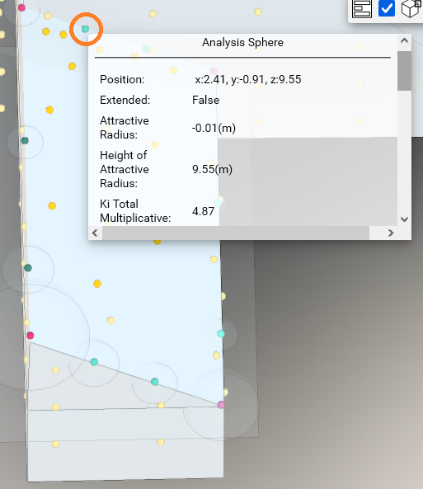

I think these are pulling GRN but I’m not concerned about 11 & 12

POI 12:



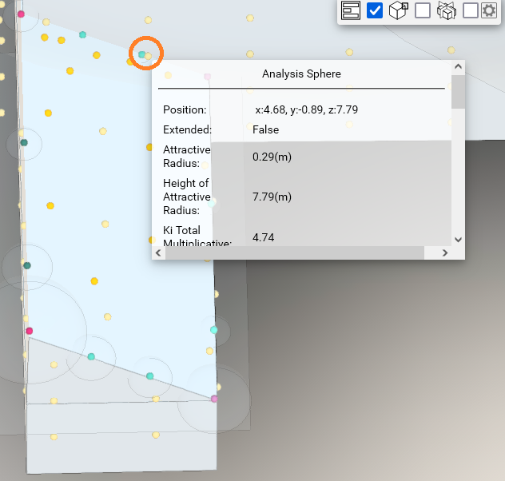

I think these are pulling GRN but I’m not concerned about 11 & 12

POI MAP:

